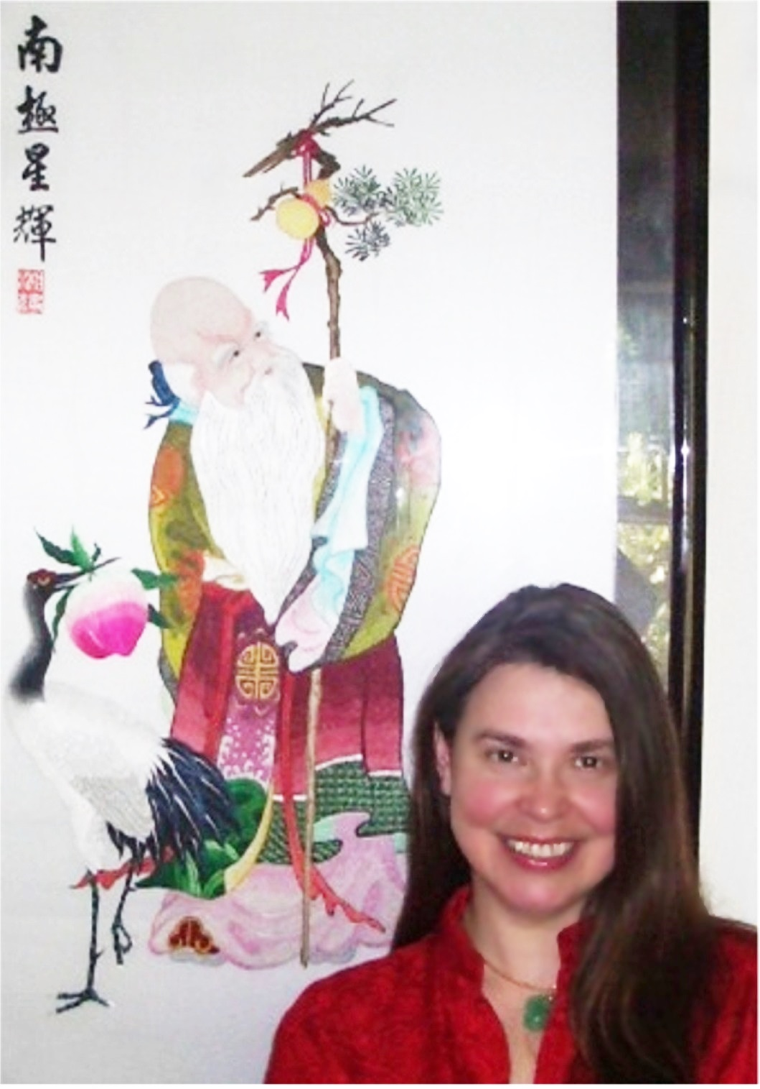

Lada Ray's Original Life-Shifting Ritual

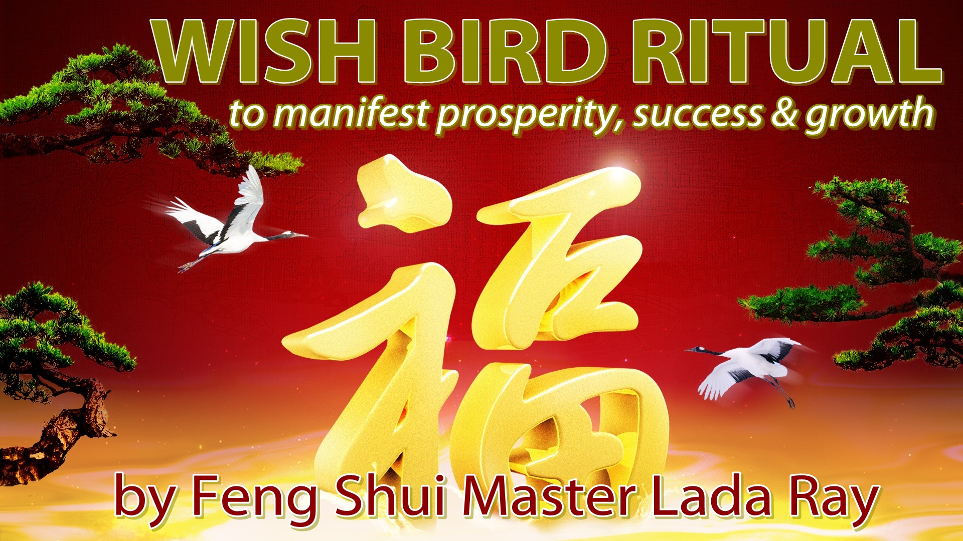

WISH BIRD RITUAL
by Feng Shui Master Lada Ray

to usher in fabulous luck
and manifest your heartfelt wishes

Who doesn't like birds!
In this very special edition, Lada Ray shares her favorite Wish Bird Ritual. Based on Feng Shui and Chinese lore, it far surpasses the Chinese and Asian cultures.

Lada Ray created this very special ritual, combining the wisdom of many cultures, including Russian, Western, plus shamanic cultures of Siberia and America, and borrowing the very best from each. The ritual is fun to do, it's suitable for any age and can be performed together with your children. No special knowledge or training required!

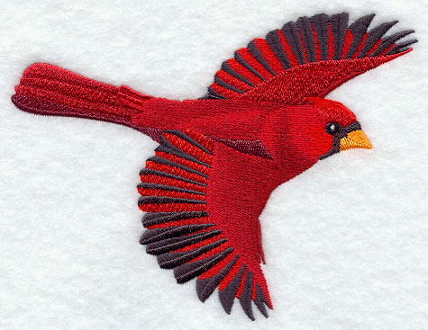

Preparation

You will need to buy a flying bird at one of your local craft stores or markets. In the US they are sold at Michaels and A.C. Moore. Also try stores like Hallmark, Pier 1 and fair trade stores, such as Ten Thousand Villages.
In various counties of Latin America local handmade crafts are sold on streets and markets. In Russia there are also plenty of markets and fairs where traditional crafts are sold. There you can find fabulous wood-carved and beautifully painted birds.

I've seen birds hand-made out of metal, glass, Swarowski crystal, shells and mother of pearl. Be creative and find those birds that feel right, ignite your imagination and call to you!

Various countries will have their own traditions and their own stores – explore them and think creatively.

Suitable kinds of birds for this ritual are

Red cardinal, swan, stork, egret, crane, eagle, hawk, owl, seagull, dove, hummingbird, goose, duck.

OR birds of legend and lore: Chinese phoenix, Russian firebird, angel bird.

Examples of the birds that work
These are small-sized images – find large-size images, which you may print and use in your Wish Bird Ritual, at the need of this report!

Crane:
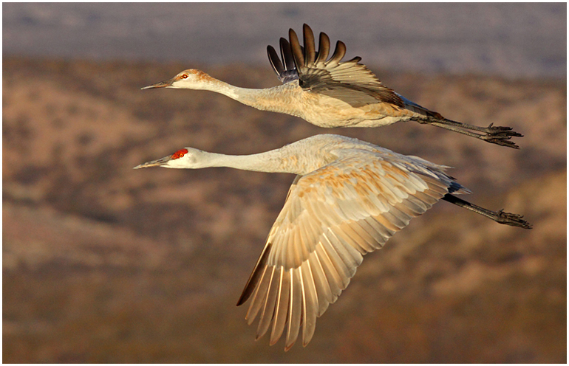

Phoenix:

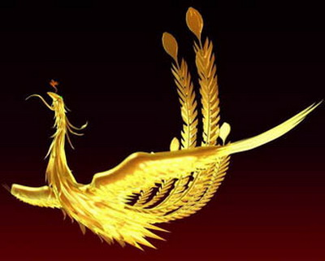

Beautiful wood-carved birds (but yours don't have to be as expensive)
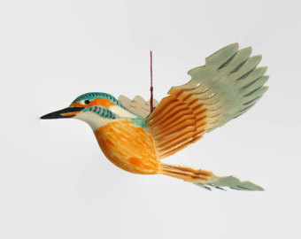
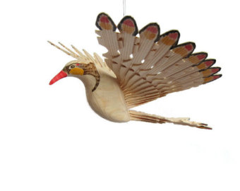

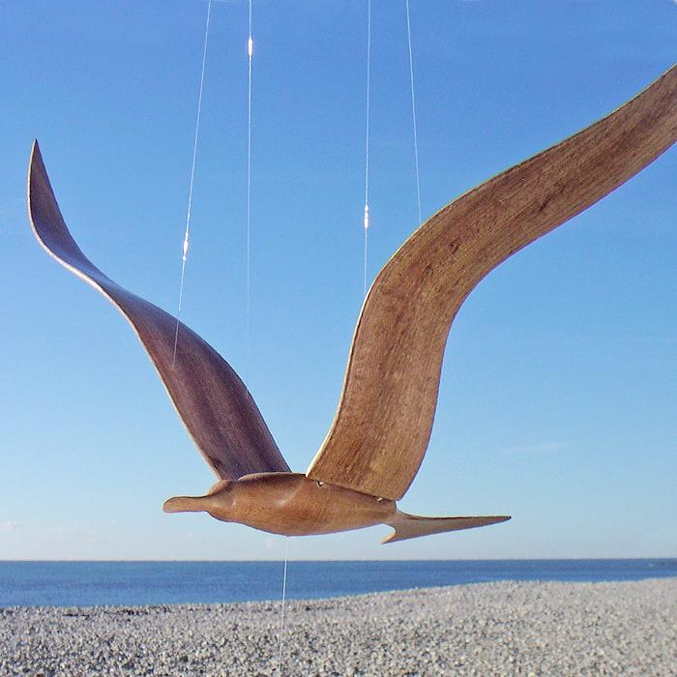

Wood-carved seagull mobile

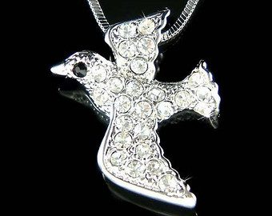

Swarowski crystal bird

VERY IMPORTANT! The bird has to have outstretched wings and appear to be flying.
If you can’t find a flying bird I've described, then, from the internet, print a quality full page image of a flying bird.

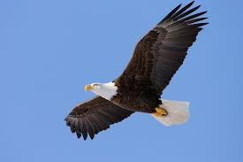

Once, to sell a house, I used a color pic of a flying eagle I printed from the Internet. The house sold above market, for the amount I wanted, which was unheard of for that area before my sale, and the buyers were very nice and accommodating.

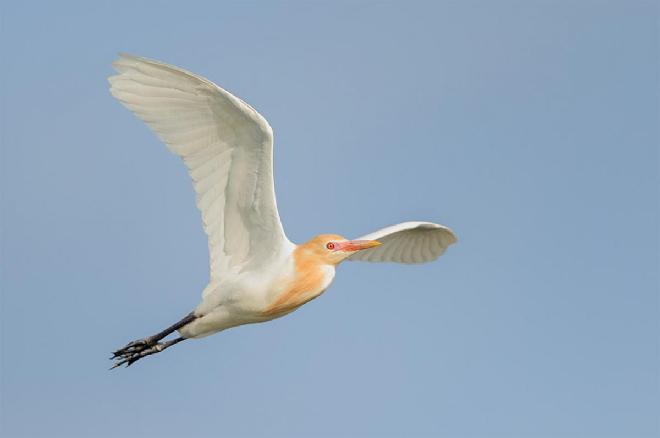

The bird symbolism

The sale of a home is just one example. Generally, this ritual seems to work very well for any sort of home sale, purchase or relocation-related sacred wish. This is due to the fact that birds often fly to far away lands and they are associated with travel and annual migration or relocation.
Birds are also famous for their nest-building techniques and wonderful home and family ethics.

But that's not all! In addition, birds in many cultures are the bearers of good news, such as postal pigeons in the old days. Cranes are associated with peace, luck, health, fertility and children. Doves are symbols of peace, love and spirituality. Eagles and other birds of prey are famous for their speed, agility and vision, as well as their ability to unite heaven and earth. Seagulls are the symbol of uniting in one 3 different realms: sea, sky and earth. Geese (also ducks) are a symbol of relocation and far away travels. Hummingbird symbolizes destiny, endurance, courage despite odds. Ducks – fertility and family. Stork – family, fertility, good news. Red cardinal – good luck and good news. Owl – night vision and wisdom. Hawk: patience, timing and discernment.

There are many other great birds and awesome examples of how beautiful and important birds are for humans and for our Mother Earth. Try to choose the bird that corresponds with your wish based on bird symbolism above.

Therefore, you can apply this treasure of a ritual for any sacred wish you hold dear to your heart. Anything from a life-shifting relocation and financing of a dream, to family, career and spiritual development will work.

The KEY is to approach your wish with pure and loving heart.

Performed from greed, jealousy, fear or any other lowly emotion, this ritual won't work. For example, don't try wishing to get rich quick.

Incidentally, for prosperity and abundance see the 6 PROSPERITY ENVELOPE RITUALS.

Another example of a wish that probably isn't suitable is to make someone fall in love. In fact, something like this may backfire – matters of the heart are very delicate and have to take natural course.

What works:

Wishing based on your heart's sacred desire to improve your life, find your true destiny, your new career that is in line with your growth, your true spiritual path – these Wish Bird wishes work wonderfully! And of course, as mentioned previously, anything to do with relocation, sale or purchase of your home (and business) is also fabulous.

How the Wish Bird works

Your Wish Bird is your messenger of good will to the Universe.

The outstretched wings of your bird, flying free into the sky, will work to carry your heartfelt wish to the Universe, signaling that you are ready, committed and focused on the manifestation of your heartfelt desire.

Therefore, be responsible and wish for something that you really, truly want!

HOW TO PERFORM THE RITUAL

If you like, you may light incense, sage and/or candles. It is a good idea to cleanse your bird with sage or incense before the ritual.

Formulate your wish very clearly. What do you want? What benefits do you want to achieve as a result of your wish being fulfilled? Visualize the wish being fulfilled and the benefits you'll receive. How will your life change? What do you love about this change your so desire? Visualize all this and stay positive throughout the ritual.

Write your wish in a few succinct words on a small piece of paper in red ink.
Examples: “I move to a new happy home I love.” Or: “I find the career where I can grow to my best potential.” Or a similar straightforward phrase that resonates with you. Do not make it too complicated, because it will confuse matters. Do not be too specific with details – trust the Universe to make the right decision as to what home is right for you, or what is right for your growth.

In the above example with the sale of my house, I simply wrote down the amount I wanted for the house on a piece of paper, and taped that piece of paper to the beak of my birdie, so it would appear as if it was carrying my wish in its beak. You can also tape it securely to the flying bird's wing, back, or tie it around her neck.

In my home sale example I put the picture of my color-printed eagle in a nice golden frame and hung it on my covered front porch, next to my front door, flying out and carrying my wish to the Universe in its beak.

If you have a balcony or porch, hang the bird there, facing out. If it's a picture, hang it on the wall facing out. It works best when it’s hung outdoors.

If you don’t have any outdoor space, hang it inside, near your front door or window that gets opened every day (or open it regularly). The idea is that the bird needs to be able to fly outdoors (NOT into a corridor, if you live in an apartment) unimpeded, to deliver your wish to the Universe.

After this, trust the Universe will hear your heartfelt wish and… forget about it. Don't worry. As they say in Ireland, what's for you, won't go by you.

My Chinese Feng Shui teachers think that the Wish Bird is especially potent if the ritual is performed during Chinese New Year celebration, especially on the first day. First day of Chinese New Year of the Rooster is January 28, 2017. The celebrations last for 2 weeks. Performing this ritual any time during Chinese New Year celebrations is very auspicious.

But I say, your wish bird will be especially dear to your heart and potent when you feel the strongest about your wish. If you think today is the best day for your birdie to fly – do it! If you have a sacred wish, don't delay.

Incidentally, since rooster is a bird, and the only bird sign of the Chinese Zodiac, the Rooster Year 2017 makes the Wish Bird ritual especially potent. So, don't waste it!

Best of luck and may all your sacred wishes come true!

Yours always,

Lada Ray

Created by Lada Ray on December 6, 2016. Updated January 13, 2018

COPYRIGHT LADA RAY. ALL RIGHTS RESERVED.

***Large-sized bird images are included on the following pages. You may print these and use them for your ritual!

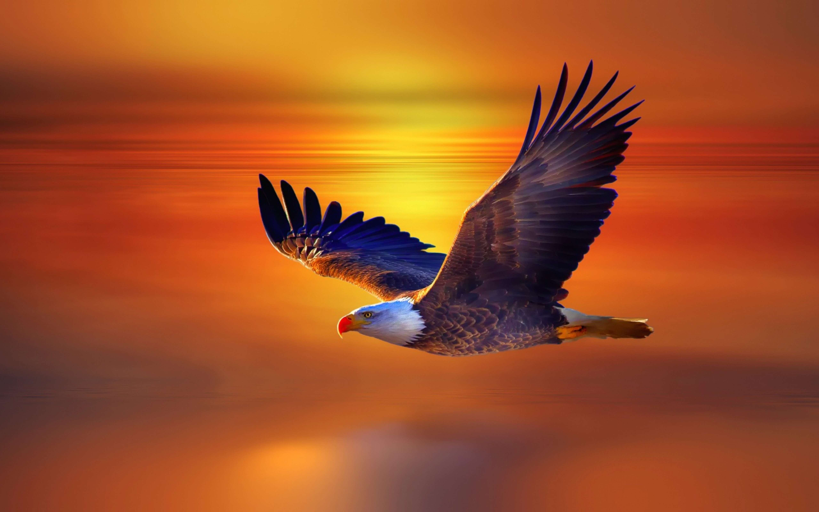

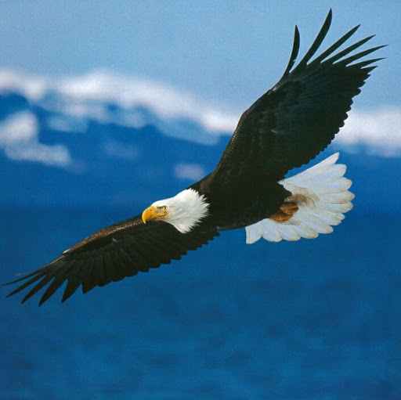

COPYRIGHT LADA RAY. ALL RIGHTS RESERVED.

Visit: LadaRay.com EARTH SHIFT SYSTEM

CONSULTATIONS WEBINARS BOOKS

Follow: FuturisTrendcast Lada Ray YT Twitter

Support Lada Ray'c cutting-edge work, get exclusive content and take part in the creation of future books!
SUBSCRIBE TO LADA RAY ON PATREON



Click for a FREEBIE & affordable
LADA RAY MANIFESTATION RITUALS
(written mini-reports)

Click for Lada Ray Feng Shui (including FREE articles!)





NEW! GREAT GIFT!

LADA RAY MANIFESTATION RITUALS
(written mini-reports)

Ancient Eastern magic, Feng Shui secrets & spiritual revelations
to help you live
a happier, healthier, more harmonious & prosperous life!

Step-by-step tutorials, spectacular pics & case studies in each report!
Super-affordable, easy and effective!

ALL RITUALS & MANIFESTATION REPORTS ON BIG HOLIDAY SALE!
Starting at $3.69! All under $10!
+ a FREEBIE!

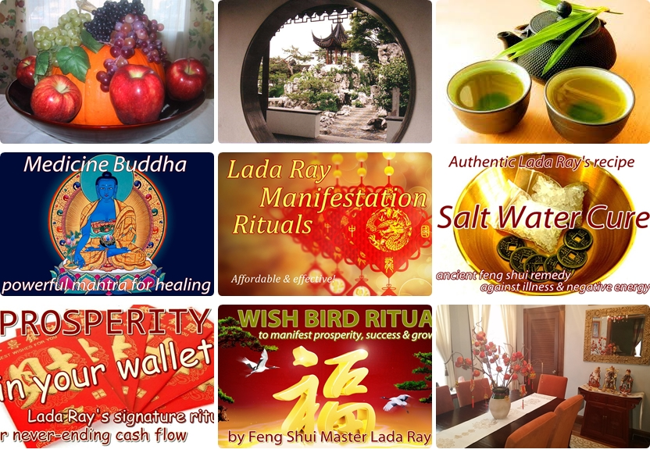

LADA RAY CONSULTATIONS (skype & written)



