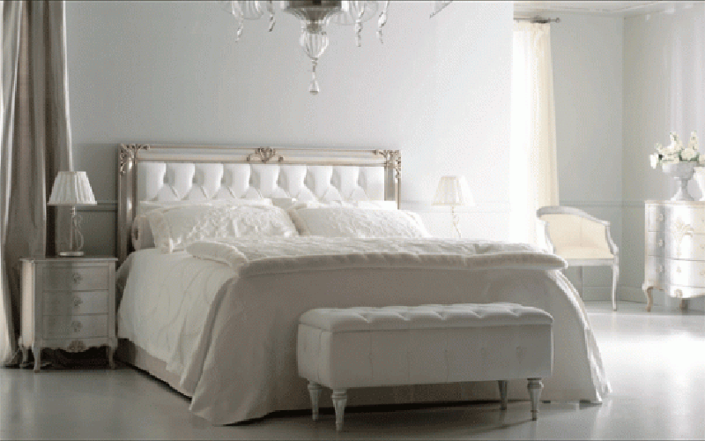

Secrets of Effective De-Cluttering:

Reclaim the Health of Your Space!

ORIGINALLY PUBLISHED IN MAGIC BIRD FENG SHUI, 2005

Copyright Lada Ray. All rights reserved.

WHEN SEVERAL PEOPLE IN ONE DAY APPROACHED ME WITH THE SAME

QUESTION:

“HOW DO I DE-CLUTTER MY HOME or BUSINESS SPACE?”

I KNEW THE TIME FOR THIS ARTICLE HAS COME!

In Feng Shui terms, clutter represents stagnant, old, or even dying energy. It prevents the free flow of Chi, the life-giving force that is necessary for us to feel vibrant, positive, successful, and have you guessed? …HAPPY.

It has become a cliche of sorts, everyone knows they need to de-clutter. In our consumer oriented society having many things – some unfortunately useless – is a norm.

We buy things & clothes when we feel down, when we need a boost, when we want to lift our spirits. The logic behind that is correct: new items brought into our space bring fresh energy with it. However, here is a problem: when you buy while feeling sad or depressed, chances are you will buy the wrong item(s). Items you have no use for will reflect your low energy level & your state of mind at the time. It is like eating cake when we feel lonely or depressed – we want to boost our energy, instead we are cluttering our body with waste.

The same happens with our home or office. When feeling lonely, depressed, or wanting to bring a new energy into your space, buy high quality uplifting art, crystals, great music, or acquire high quality & effectiveness Feng Shui remedies & energizers, designed specifically to boost the CHI level! Much like eating fruit instead of cake, and vitamins & minerals instead of beer will strengthen the life force of your body, such items will increase health & vitality of your space!

Going back to the issue of de-cluttering. While you may know you need to de-clutter, you may feel it is too much of an effort. Some get discouraged in the middle of the project & abandon it all together. How to start & what to focus on seem to be the main questions.
Here is some advice I give to my clients when I hear such complaints:

Do your de-cluttering little by little. When you de-clutter, you stir up a ton of wasteful, stagnant energy. Much like when you are cleansing, all those toxins get stirred up in your body and temporarily you feel worse before you start feeling better. Same happens to your house. When you cleanse, if you do too much too fast, you may get sick. When you de-clutter too fast, your life may get worse temporarily as well! That is why sometimes de-cluttering projects get abandoned before completion.

Solution: de-clutter slowly, one room, or corner at a time. Gradual de-cluttering will allow your space & your psyche adjust to the new energy flow. Then rest a little & start a new corner, or a new room. Pace yourself over a course of a few weeks or months. At that time, bring only meaningful items into your space. Use highly effective, thoughtfully acquired Feng Shui remedies & energizers (do not buy cheap trinkets – they are ineffectual & sometimes even harmful).

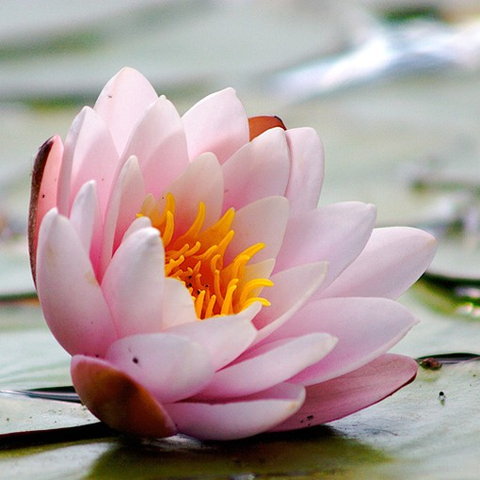
Another important point: let your space tell you what your de-cluttering priorities are. Do not assume anything. One of my clients, when I told her this, said, “This makes sense! Sometimes, I would start de-cluttering the office, but it is like some kind of force is pulling me to the bedroom instead”. Do not resist that force! Our home, or office, believe it or not, is a living, breathing entity. It has its own mind, its own needs & preferences.

Listen to it, tune into its vibrations. You may be amazed how much it will tell you!

An example I often cite is that of my uncle. It took me several years to convince him to de-clutter the South East corner of his property. The South East in Feng Shui is responsible for wealth & prosperity. I had a hunch that my retired uncle never allowed himself to travel because he felt insecure spending his retirement money & the clutter in the South East corner was a contributing factor. We systematically cleared stacks of old magazines & papers accumulated there for years. The whole project took us a few weeks & in the end we felt exhausted. After it was complete, we uncovered some important missing papers, including cash & some greatly appreciated stock certificates.

My uncle thought it was a miracle! Apparently our de-cluttering efforts have liberated the energy of prosperity, as well as my uncle’s wealth luck that has been suffocating in that corner for years. His space literally started breathing. My uncle sold his stocks just on time: right before the crash & at the top! He used that money to boost his energy & horizons through world travel with his newly found sense of prosperity.

Just like with the above example, clutter in any corner of your home or office usually is a sure sign & a contributing factor to all kinds of problems in your life. When I am called on a Feng Shui Consultation, clutter immediately tells me what area of my client’s life is not flowing right. Invariably, my conclusions are confirmed by client’s complaints.

Try to develop mindfulness toward clutter-induced life problems. For example, clutter in the kitchen indicates that residents are overwhelmed by the house maintenance. Clutter in closets indicates unwillingness or inability to deal with hidden issues. And clutter in the attic is a sign of not being able to part with the past.

A word of caution! While de-cluttering, do not inadvertently create the opposite problem. It is important not to get carried away & overdo things. Try not to clutter your space, but do not make it look too bare or clinical either. That applies not only to your living space, but also to your office. Avoid the sterile, impersonal appearance that government offices, hospitals, and military installations are notorious for. Such places possess too much lifeless metal energy. Other examples are computer, machinery or trading rooms.

One of the neatest homes I have ever seen belonged to a financial consultant with a major wirehouse. He was certainly in no danger of clutter! In fact he feared clutter so much, that he would obsessively clean every day. Frankly, I’ve never seen a man’s home so neat. So neat in fact, that you felt uncomfortable staying there. Have you guessed, that the man had no life, except for his job?

So, remember that balance is key in Feng Shui!

Ok, so we have successfully completed our de-cluttering process. Now what?

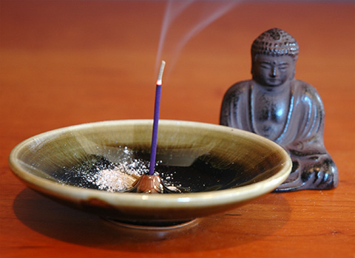

An exceptionally good compliment to de-cluttering is space clearing.

There are some very good space clearing methods available on the market. Do your research to come up with the space clearing method that suits your needs.

After all the dust (literally & figuratively speaking) has settled, we have made room for new, fresh energies. So fill it only with positive, life affirming energies of success, prosperity, joy, great relationships & wisdom. Just like filling your body only with good foods will give you more energy, filling your home or office only with high quality meaningful items, music, flowers, Feng Shui symbols & energizers will propel your life to the new exciting levels of accomplishment, peace & happiness.

COPYRIGHT LADA RAY. ALL RIGHTS RESERVED.

Visit: LadaRay.com EARTH SHIFT SYSTEM

CONSULTATIONS WEBINARS BOOKS

Follow: FuturisTrendcast Lada Ray YT Twitter

Support Lada Ray'c cutting-edge work, get exclusive content and take part in the creation of future books!
SUBSCRIBE TO LADA RAY ON PATREON

Click for Lada Ray Feng Shui (including FREE articles!)
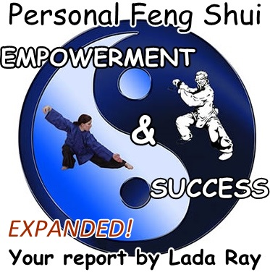

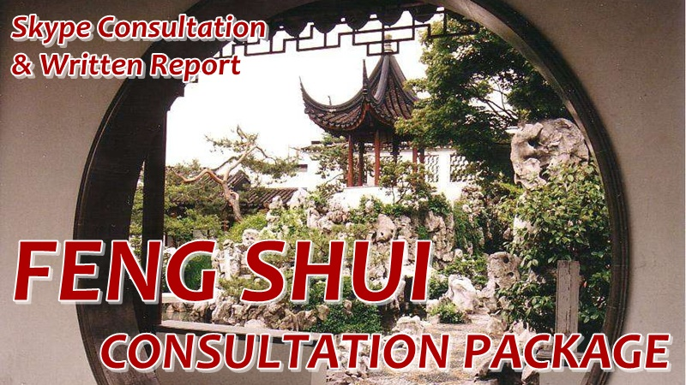

NEW! GREAT GIFT!

LADA RAY MANIFESTATION RITUALS
(written mini-reports)

Ancient Eastern magic, Feng Shui secrets & spiritual revelations
to help you live
a happier, healthier, more harmonious & prosperous life!

Step-by-step tutorials, spectacular pics & case studies in each report!
Super-affordable, easy and effective!

ALL RITUALS & MANIFESTATION REPORTS ON BIG HOLIDAY SALE!
Starting at $3.69! All under $10!
+ a FREEBIE!

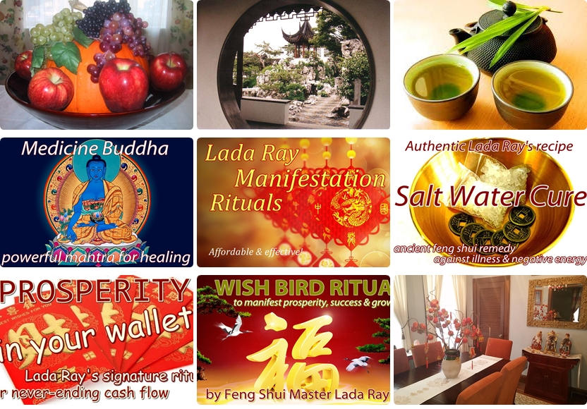

LADA RAY CONSULTATIONS (skype & written)

